Business Question and Visualization Report
Date | 21-Aug-2026
Team ID | Individual
Project Name | Food Delivery Analytics: Customer Behaviour & Operational Insights
Maximum Marks | 5 Marks

Business Questions and Visualizations
No. | Business Question | Visualization in Your Tableau Workbook | Purpose / Insight
1 | What is the total revenue generated from food delivery orders? | Total Revenue – KPI Card | To measure overall business revenue and provide a quick view of financial performance.
2 | What is the average amount spent by customers per order? | Average Order Value (AOV) – KPI Card | To understand customer spending behaviour and the average monetary value of each order.
3 | What is the average delivery time for food orders? | Average Delivery Time – KPI Card | To measure overall delivery efficiency and establish a baseline for operational performance.
4 | Does higher order volume lead to longer delivery times? | Operational Bottlenecks: Order Volume vs. Delivery Time | To identify whether increasing order volume creates delivery bottlenecks and operational pressure.
5 | How does rain affect delivery time and surge fees? | Rain's Impact on Delivery Times and Surge Fees | To understand the effect of rainy conditions on delivery efficiency and additional delivery charges.
6 | What percentage of orders are repeat orders? | Repeat Order % – KPI Card | To measure customer retention and understand the level of repeat purchasing behaviour.
7 | Which cuisines generate the highest revenue? | Total Revenue by Cuisine & Restaurant Type | To identify high-performing cuisines and understand where revenue is concentrated.
8 | What are the most preferred cuisines among customers? | Customer Preferences Across Cuisine – Donut Chart | To identify customer preferences across Biryani, Chinese, Desserts, Fast Food, North Indian, and South Indian cuisines.
9 | Which restaurant types generate the highest revenue? | Total Revenue by Cuisine & Restaurant Type | To compare restaurant types and identify categories contributing strongly to revenue.
10 | What are the key operational factors affecting food delivery performance? | Operational Bottlenecks + Rain Impact Analysis | To identify major operational challenges and understand factors that can affect delivery efficiency.
- What is the overall food ordering performance?
Visualization: KPI Cards
Attributes:
- Measure: Total Revenue
- Measure: Average Order Value
- Measure: Repeat Order %
- Measure: Average Delivery Fee

Screenshot:

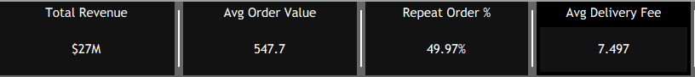

2 Which cuisines and restaurant types contribute the most to total revenue?
Visualization Treemap
Attributes:
- Dimension: Cuisine
- Dimension: Restaurant Type
- Measure: Total Revenue
Screenshot:

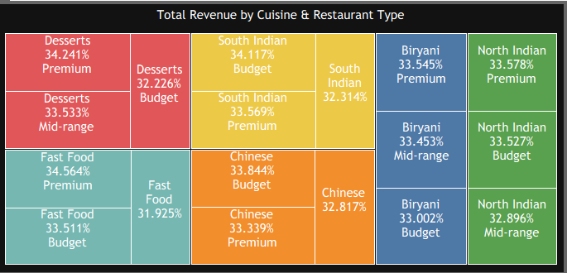

- How does repeat-order behaviour vary across different customer moods?
Visualization: 100% Stacked Bar Chart
Attributes:
- Dimension: Mood
- Measure: Repeat Order %
- Measure: Number of Orders
- Color: Repeat Order Status
Screenshot:

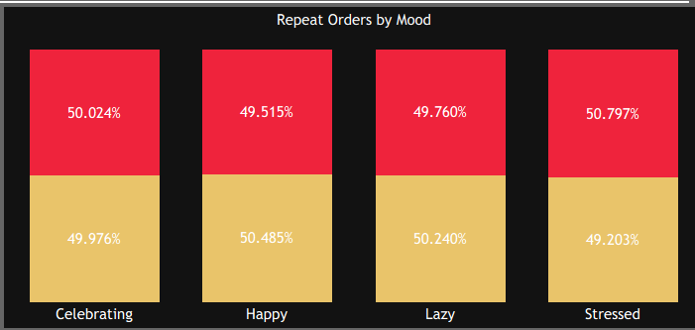

- How does order volume vary with delivery time?
Visualization: Dual-Axis Bar and Line Chart
Attributes:
- Dimension: Delivery Time
- Measure: Order Volume
- Measure: Delivery Time

Screenshot:

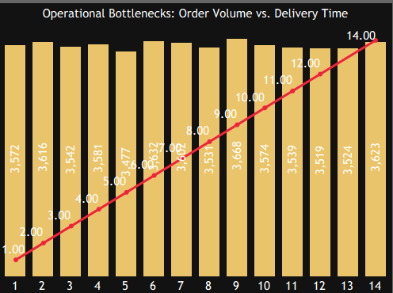

- How are weekday and weekend orders distributed across cities?
Visualization : Stacked Bar Chart
Attributes:
- Dimension: City
- Dimension: Day Type
- Measure: Order Count
- Color: Weekday / Weekend

Screenshot:

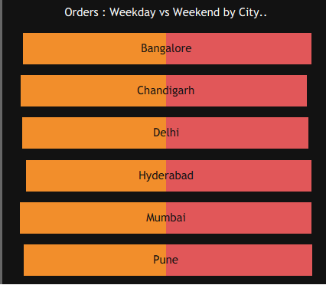

- How does rain affect delivery time and delivery fees?
Visualization : Box Plot / Distribution Chart
Attributes:
- Dimension: Rain / Weather Condition
- Measure: Delivery Time
- Measure: Delivery Fee

Screenshot:

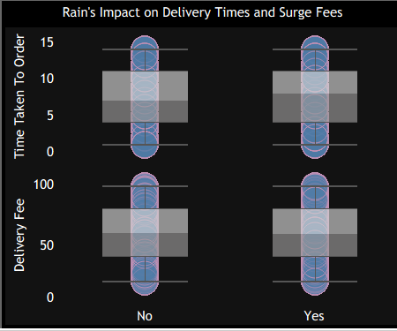

- Which cities generate the highest order volume?
Visualization: Ranked Horizontal Bar Chart
Attributes:
- Dimension: City
- Measure: Number of Orders
Screenshot:

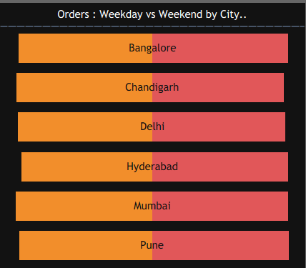

- Which cuisines are most preferred by customers?
Visualization: Treemap
Attributes:
- Dimension: Cuisine
- Dimension: Restaurant Type
- Measure: Total Revenue

Screenshot:


